PUTTING THE TOWN IN A COMPARATIVE PERSPECTIVE

Other suburban towns are as or even more wealthy and have lots more prestigious national retailers – and their retail also is hurting, a lot. Part of Larchmont’s problems are Larchmont based, but strong national trends are also at play

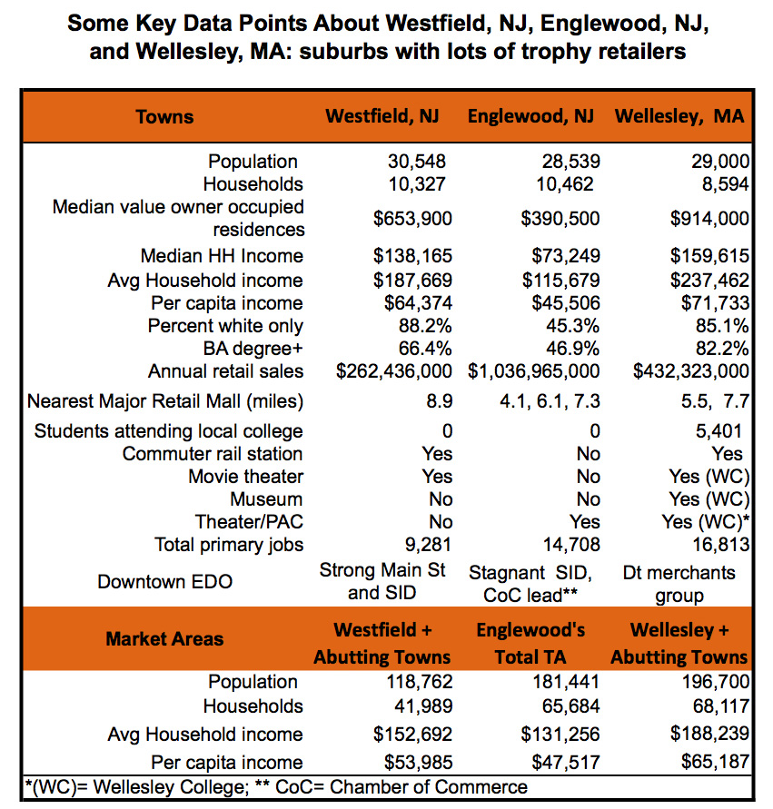

Median Home value in Larchmont $1,044,800; median HH income $152,284.
Median Home value in Mamaroneck TOWN $816,300; median HH income $114,273.

